**Overutilization in Healthcare**

Advith Chelikani, Nick Haliday, Logan Cross

**Problem**: Under the fee-for-service model, doctors’ income is based on the procedures they perform and tests they order. This incentivizes doctors to maximize the number of tests/interventions, even when this has zero or even negative marginal return for health. The latter case typically occurs when the ill effects of further testing or interventions in response to false positives outweigh any gain due to catching the rare true positive early. This pattern occurs, for example, in excessive testing for prostate and breast cancer at ages above 75. Additionally, imaging procedures, surgery, and prescription drugs come with numerous side effects and potential complications that can often impair health outcomes more than they benefit.

This problem of excessive testing and intervention is referred to as overutilization, and, according to many estimates, it is responsible for about a third of healthcare spending in the US ($750 billion a year out of $2.6 trillion). Reducing overutilization would help tame ballooning healthcare costs and even improve healthcare quality and outcomes. The ideal solution to this problem would be to systematically switch to value-based models of healthcare, which creates incentives for health systems to increase the value and quality of care rather than the volume. In these value-based models, providers, insurance companies, and hospitals are held accountable for the quality and cost of care, as their profit or incomes are determined by a patient’s health outcomes and cost. Short of this, we would like to make concrete, incremental recommendations to both providers and regulators of ways to avoid overutilization. As a movement towards a value-based system begins to occur throughout the country, organizations like the Dartmouth Atlas Project and American Board of Internal Medicine Foundation have identified low-value tests and procedures that symbolize waste and low quality health care. In their recent Choosing Wisely initiative the ABIM Foundation has outlined over one hundred evidence based recommendations to reduce waste. In this analysis, we analyzed the regional variation of six low-value tests, treatments, and procedures and identified correlates of low-value care throughout the country via a linear regression analysis.

**Goal**: To highlight the correlates of low-value care and overutilization in the United States by examining regional variation in the prevalence of six low value tests, procedures, and treatments.

**Methods:** Initially, six low-value operations were selected based on analyses done by the Dartmouth Atlas Project and the Choosing Wisely initiative. The list includes: 1. Males over the age of 75 having a screening prostate-specific antigen (PSA). 2. Females over the age of 75 having a screening mammogram 3. Patients with dementia receiving a feeding tube during the last 6 months of life 4. Routine electrocardiograms for patients with no symptomology 5. Prescription of opioids for patients with migraines 6. Hip, knee, and shoulder replacement surgery except as a last resort.

Recent analyses have observed large unwarranted variations in the use of these procedures across the country (Weinberg, 2014). However, it is large unknown what factors contribute to or are associated with this variation in overutilization. To uncover regional characteristics associated with low-value care, we performed regression analyses with each of the six procedures and estimated the direction and magnitude of correlated explanatory variables. All data is based on publically available Medicare claims data and is taken from the year 2012. Explanatory variables were taken from Factual health care datasets, online medicare datasets (https://www.cms.gov/) and the Dartmouth Atlas online datasets (http://www.dartmouthatlas.org/). The Factual dataset was used to estimate the density of specific types of doctors within a region. This was used to estimate the relationship between the concentration and market competition within a specialty, and the prevalence of a procedure or treatment ordered by that specialty (ie. cardiologists and ECGs; primary care physicians and PSAs/ mammograms). A medicare Part D utilization dataset was used to measure the amount of opioid prescriptions given to patients with migraines. The remainder of the data was retrieved from the Dartmouth Atlas website. Regional variation was measured at the level of a Hospital-Referral-Region (HRR), which represents regional healthcare markets at the size of 1-5 counties. All dependent and explanatory variables were normalized via z-score. Explanatory variables are represented in table 1.

**Table 1. Explanatory Variables at the HRR-level**

|  |  |
| --- | --- |
| **Explanatory Variable** | **Data Source** |
| Density of doctor types | Factual |
| Specialist to Primary Care ratio | Factual |
| The average number of contact days with the health system per Medicare beneficiary | Dartmouth Atlas |
| The percent of beneficiaries whose predominant provider was a primary care physician | Dartmouth Atlas |
| Average number of unique clinicians seen per beneficiary | Dartmouth Atlas |
| Average annual percent of Medicare enrollees having at least one ambulatory visit to a primary care clinician | Dartmouth Atlas |
| Average number of hospitalizations for ambulatory conditions (conditions that should be handled out of hospital) | Dartmouth Atlas |
| Hospital care intensity index (standardized ratio of inpatient days and inpatient visits) | Dartmouth Atlas |
| Average payments for physician visits | Dartmouth Atlas |
| The number of hospital beds per 1,000 beneficiaries | Dartmouth Atlas |
| The number of surgical beds per 1,000 beneficiaries | Dartmouth Atlas |
| Average number of visits to a specialist per decedent (last two years of life) | Dartmouth Atlas |
| Average number of visits to a primary care physician per decedent (last two years of life) | Dartmouth Atlas |
| The ratio of specialist to primary care visits per decedent (last two years of life) | Dartmouth Atlas |
| Percent of deaths occurring in hospital | Dartmouth Atlas |
| The number of hospice days per decedent | Dartmouth Atlas |
| Number of different physicians seen per decedent during the last two years of life | Dartmouth Atlas |
| Average number of 30-day prescription fills per beneficiary | Dartmouth Atlas |
| Percent of beneficiaries filling at least one prescription for a high-risk medication | Dartmouth Atlas |
| Proportion of 30-day prescriptions filled with brand-name products | Dartmouth Atlas |

This large set of variables was selected to have a robust and unbiased analysis of regional variation in waste. However, this presents two problems for regular linear regression. First, interpretation may be difficult with a large number of variables and many variables may be unassociated with the outcome variable. Therefore feature selection may be useful. Additionally, there is a high amount of multicollinearity with this variable set. Regular linear regression may be unstable in this case. To combat these challenges, elastic net regression was used. Elastic net is a regularization method that combines the L1 (lasso) and L2 (ridge) penalties to deal with feature selection and multicollinearity respectively. Elastic net regression consistently outperformed regular linear regressions for every analysis. An example of this performance is shown for the analysis of opioids prescribed for migraines (Figure 1). Statistical analyses were performed using python and R.

**Figure 1. Elastic Net Outperforms Linear Regression (Opioids prescribed for migraines analysis)**

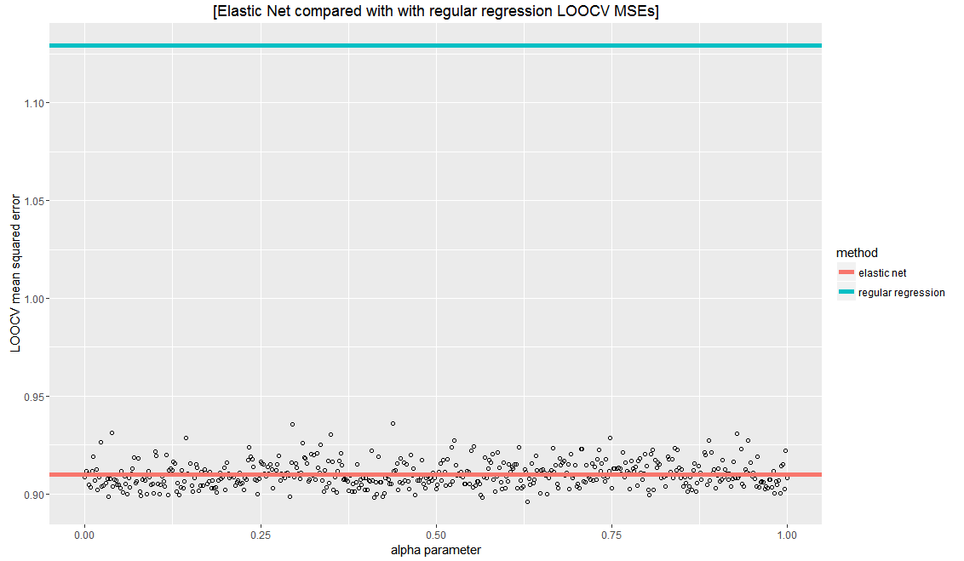

**Results:** We intended to identify small set of features that can account for most of the variance by using elastic net regularization, thus most variables were zeroed out in a highly regularized regression with mean square error one standard error from the less regularized by likely overfit model at the absolute minimum mean square error. Moreover, several characteristics has nonzero coefficients and were associated with the overuse of one or multiple low-value services (Table 2). The size of the coefficients reflects their overall contribution to the dependent variables, as all features were normalized via z-score.

As expected, the results for males over 75 having a prostate screening and females over 75 having a mammogram were very similar. As the influence of the primary care provider in a region increases, there is an associated increase in the amount of these screening tests. This is unsurprising as the primary care physician is usually the one administering the test. Furthermore, the average number of contact days with the health system and the percent of beneficiaries filling at least one prescription for a high-risk medication had an even stronger positive relationship with the prevalence of these screening tests. These variables are a reliable measure of health care use intensity, which suggests that these low-value screening tests are occurring in regions with a higher overall volume of health care utilization.

For feeding tubes placed for dementia patients, again variables associated with overall utilization and intensity were associated with the prevalence of this low-value procedure. The average number of contact days, the hospital care intensity index, and the percent of beneficiaries filling at least one prescription for a high-risk medication were all positively associated with this outcome variable. The average number of visits to a primary care physician per decedent is negatively correlated and the The ratio of specialist to primary care visits per decedent is positively correlated. This suggests that dementia patients relying on a primary care physician for their main care rather than a specialist are more likely to avoid low-quality care such as the implementation of a feeding tube. A similar relationship may occur for dementia patients ending their lives in the hospital rather than hospice. Although hospice has a multitude of benefits over the hospital for the end of life, they may be overusing feeding tubes as a treatment option as the number of hospice days per decedent is positively associated with this.

All variables identified in the analysis of routine ECGs correspond to variables indicating higher overall utilization levels and higher capacity levels for hospitals. This suggest that this high cost low-value procedure is likely occurring in regions where providers are focused on volume over value or keeping costs down.

The average number of hospitalizations for ambulatory conditions is positively associated with prescribing opioids for patients with migraines, and the average number of visits to a specialist and primary care physician per decedent are negatively associated with prescribing opioids for patients with migraines. Since migraines can be considered an ambulatory condition, it may be the case that migraine patients are often treated in the hospital regions with less access to quality outpatient facilities. Speculatively, this association may be related to the notion that neurologists in the hospital are unable to spend much time with a patient, thus they prescribe opioids to quickly treat the migraines.

Again, variables related to overall utilization are positively associated with unnecessary bone replacement surgeries, including the proportion of 30-day prescriptions filled with brand-name product, which indicates poor financial accountability of the region’s providers (generic drugs are much cheaper and chemically identical). Also, the percent of beneficiaries seeing a primary care physician at least once a year is negatively associated with the prevalence of bone replacement surgeries. Therefore, a increased focus on primary care within a region likely combats aggressive orthopedic surgeons who suggest surgery without laying out all the options and risks.

**Table 2.** **Coefficients for highly regularized models with error one standard error from the minimum**

**1. Males over the age of 75 having a screening prostate-specific antigen (PSA)**

|  |  |
| --- | --- |
| **Explanatory Variable** | **Coefficient** |
| The average number of contact days with the health system per Medicare beneficiary | 0.4719752 |
| The percent of beneficiaries whose predominant provider was a primary care physician | 0.02389067 |
| Hospital care intensity index (standardized ratio of inpatient days and inpatient visits) | 0.06042072 |
| Percent of beneficiaries filling at least one prescription for a high-risk medication | 0.2306162 |

**2. Females over the age of 75 having a screening mammogram**

|  |  |
| --- | --- |
| **Explanatory Variable** | **Coefficient** |
| The average number of contact days with the health system per Medicare beneficiary | 0.4729804 |
| The percent of beneficiaries whose predominant provider was a primary care physician | 0.03536235 |
| Hospital care intensity index (standardized ratio of inpatient days and inpatient visits) | 0.07182114 |
| Average number of 30-day prescription fills per beneficiary | 0.001447704 |
| Percent of beneficiaries filling at least one prescription for a high-risk medication | 0.2343005 |

**3. Patients with dementia receiving a feeding tube during the last 6 months of life**

|  |  |
| --- | --- |
| The average number of contact days with the health system per Medicare beneficiary | 0.1084979 |
| Hospital care intensity index (standardized ratio of inpatient days and inpatient visits) | 0.1968946 |
| Average number of visits to a primary care physician per decedent (last two years of life) | -0.001106375 |
| The ratio of specialist to primary care visits per decedent (last two years of life) | 0.08914294 |
| Percent of deaths occurring in hospital | -0.6863204 |
| The number of hospice days per decedent | 0.01080093 |
| Percent of beneficiaries filling at least one prescription for a high-risk medication | 0.08597322 |

**4. Routine electrocardiograms for patients with no symptomology**

|  |  |
| --- | --- |
| The average number of contact days with the health system per Medicare beneficiary | 0.4170771 |
| Hospital care intensity index (standardized ratio of inpatient days and inpatient visits) | 0.1253855 |
| The number of hospital beds per 1,000 beneficiaries | 0.09951975 |
| The number of surgical beds per 1,000 beneficiaries | 0.1066732 |
| Average number of 30-day prescription fills per beneficiary | 0.08988228 |

**5. Prescription of opioids for patients with migraines (using no explanatory variables related to prescriptions)**

|  |  |
| --- | --- |
| Average number of hospitalizations for ambulatory conditions (conditions that should be handled out of hospital) | 0.05909139 |
| The number of surgical beds per 1,000 beneficiaries | 0.03921942 |
| Average number of visits to a specialist per decedent (last two years of life) | -0.01612746 |
| Average number of visits to a primary care physician per decedent (last two years of life) | -0.003815692 |
| The number of hospice days per decedent | 0.04570664 |

**6. Hip, knee, and shoulder replacement surgery except as a last resort**

|  |  |
| --- | --- |
| Average annual percent of Medicare enrollees having at least one ambulatory visit to a primary care clinician | -0.01759669 |
| The number of hospital beds per 1,000 beneficiaries | 0.2235893 |
| Percent of deaths occurring in hospital | 0.2139144 |
| Percent of beneficiaries filling at least one prescription for a high-risk medication | 0.08253389 |
| Proportion of 30-day prescriptions filled with brand-name products | 0.2443913 |

**Solution and Implementation:**

This analysis mainly suggests that the variance in utilization patterns across the country is not fully due to having sicker populations in regions with higher health care intensity. As previous literature has denounced the low-value services we analyzed for nearly a decade, they should be eliminated uniformly across the country. Therefore, the prevalence of these services in particular regions is a quantitative indication of waste. Interestingly, most of the variance in these low-quality services can be explained by overall utilization patterns in a region, such as the number of contact days with the health system per beneficiary and the relative number of high risk prescriptions administered. Thus, a high prevalence of these variables is likely due to unnecessary and wasteful health care methods rather than a population with naturally poorer health.

The solution to this problem is many-fold. The main goal is to reduce the overall volume and intensity of care, which we can do by modifying doctors’ financial incentives with a value-based payment system as opposed to the current fee-for-service system. In this system, care is more integrated and coordinated and patients are charged a flat rate while providers are expected to keep their patients healthy.

Consider the following example: a patient breaks her leg. The situation is assessed and the patient pays an upfront cost of $9000 for the entire treatment process. This amount covers scans, surgery, a cast, and a follow-up appointment among other things. The doctor assumes all costs above this amount. The upfront cost is set based on an observation that previous patients with a similar damage to their leg have had treatments that have cost $7500. As such, in an ideal scenario, the doctor profits $1500 from each patient. Say the doctor does not do a good job in surgery and the patient is re-hospitalized 20 days later. Or the doctor does not convey to the patient the gravity of the injury, and the patient decides to continue to skateboard with her broken leg and ends up breaking her leg in another location as well. The doctor then fields these additional costs. While this is not a foolproof solution (some patients may try to game the system), data can be collected to further refine this process and set appropriate upfront costs.

Another component to the solution is to create an integrated and centralized repository of patient profiles. This reduces the problem of repetitive procedures, such as getting a new x-ray every time a patient is referred to a different specialist. With a well-built easily queried database of patient records, doctor can effectively propose a treatment plan without performing unnecessary tests and have no incentive to force patients to take scans that other doctors have already prescribed. Additionally, this system can be programmed to automatically ask a doctor a series of questions when he orders a risky or expensive test. This method is currently utilized at the Group Health medical home in Seattle. For example, a group of orthopedic surgeons and radiologists constructed a series of criteria a patient would need to meet to qualify for an MRI scan on a sore shoulder. If the patient does not meet the criteria, alternative recommendations such as physical therapy are automatically displayed.

Finally, with this new method of keeping track of patient data, preventive medicine can be better introduced into the healthcare system. Data collected on patients and their conditions can be used to create machine-learning algorithms that detect potential health problems in patients before they manifest themselves. Doctors can then inform patients who are at higher risk for certain diseases and can shift their focus between patients appropriately. Moreover, analysis can be done on specific procedures to identify them as redundant or unnecessary (as we have done in this paper).

Overall, a value-based healthcare system will align doctors’ financial incentives with the well-being of patients. This coupled with a centralized patient profile database and increase preventative analytics will give rise to a more focused and effective age of healthcare.

Bibliography

Wennberg, J. E. (2014). Forty years of unwarranted variation--and still counting. *Health policy (Amsterdam, Netherlands)*, *114*(1), 1.